Maksym Tereshyn
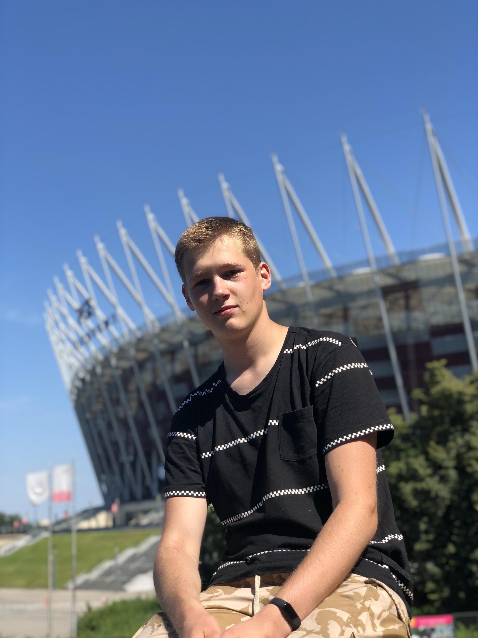
Phone: +380953577574
E-mail: max.tereshyn@gmail.com​

Portfolio: https://mtereshyn.github.io/
GitHub: https://github.com/mtereshyn
LinkedIn: https://www.linkedin.com/in/maksym-tereshyn-b50a051b9/

Goal:
To obtain position of a Markup/FrontEnd Developer.

Skills:
- HTML5
  - BEM methodology
- CSS3
- Basic JavaScript
- Adobe Photoshop
- C-language
  - I have my own game built with Ncurses graphic library

Education:
2018-present
Kharkiv National University of Radio Electronics, Computer Engineering

Language:
English (B1/B2)
Russian (Native language)
Ukrainian (Native language)

Personal information:
I am Markup Developer with HTML/CSS and Basic JS skills. Good team player, so can easily join a new team.
I have ambitions to grow and develop myself. In working process I am responsible, communicative, work well individually as well in the team.

Hobbies:
Football, programming, photography, reading, traveling.

